How to Use NetTutor

- NetTutor is available in any AU course and can be accessed from the course’s main menu on the left.

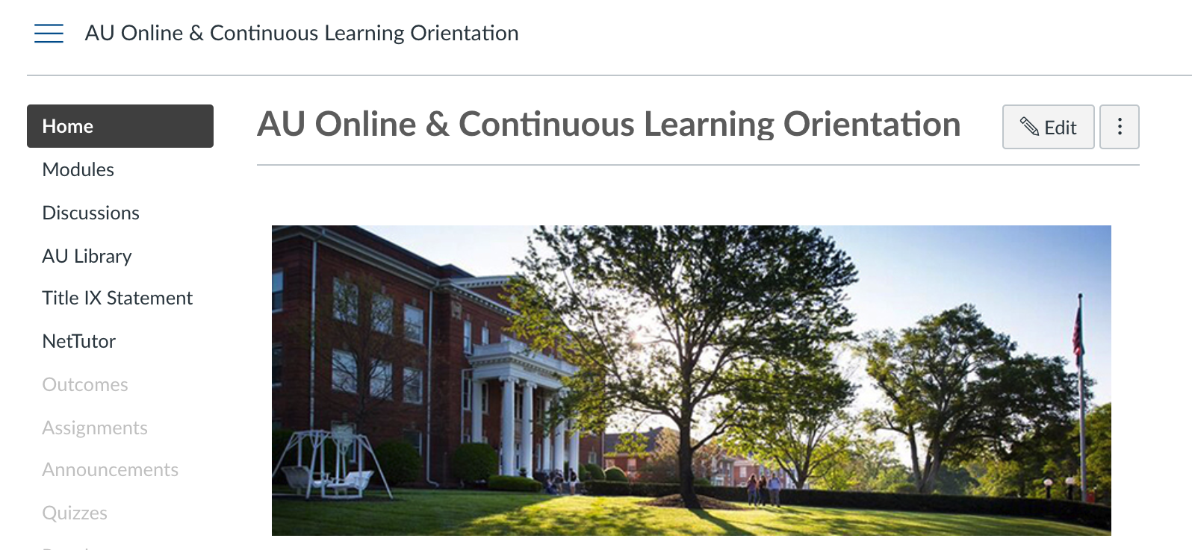

- Click the NetTutor option in the course menu and read the reminder. You may choose “Don’t show this message again” and then click “Continue”.

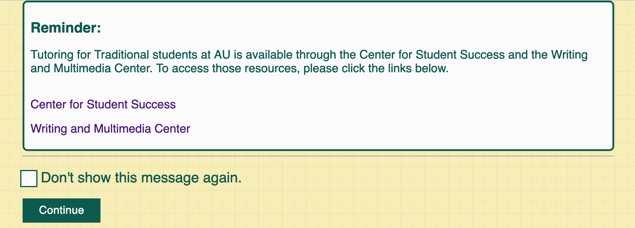
2
2
1

- Choose the content area for which you need help.

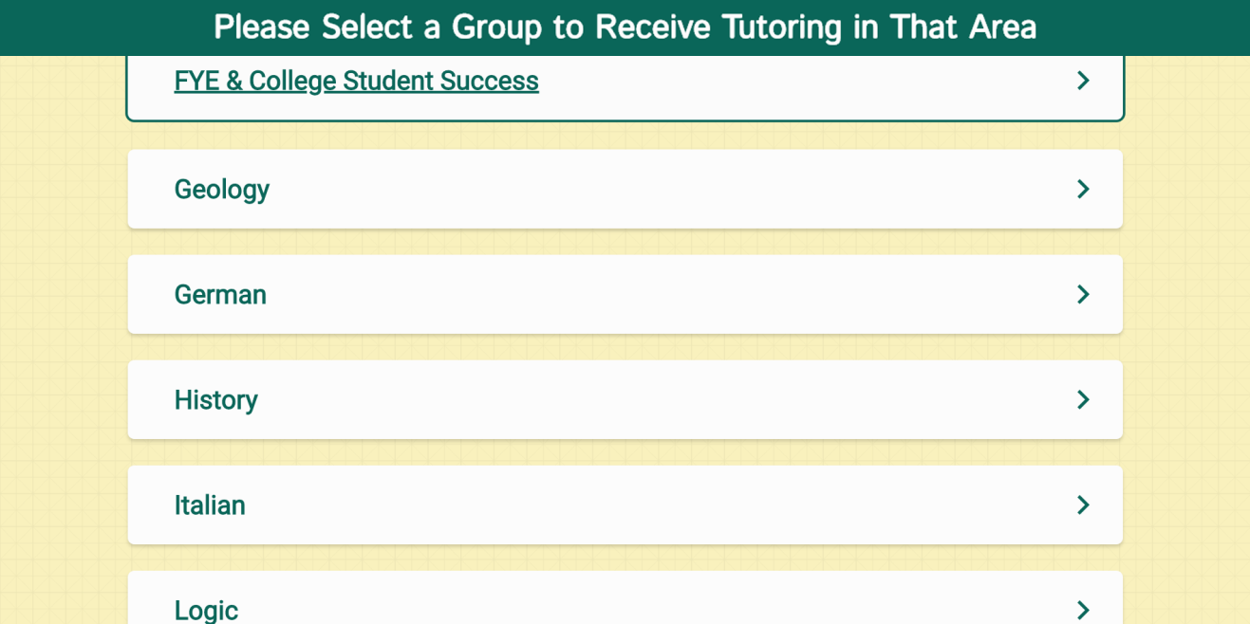

- The NetTutor dashboard provides 3 support resources, as well as a locker.

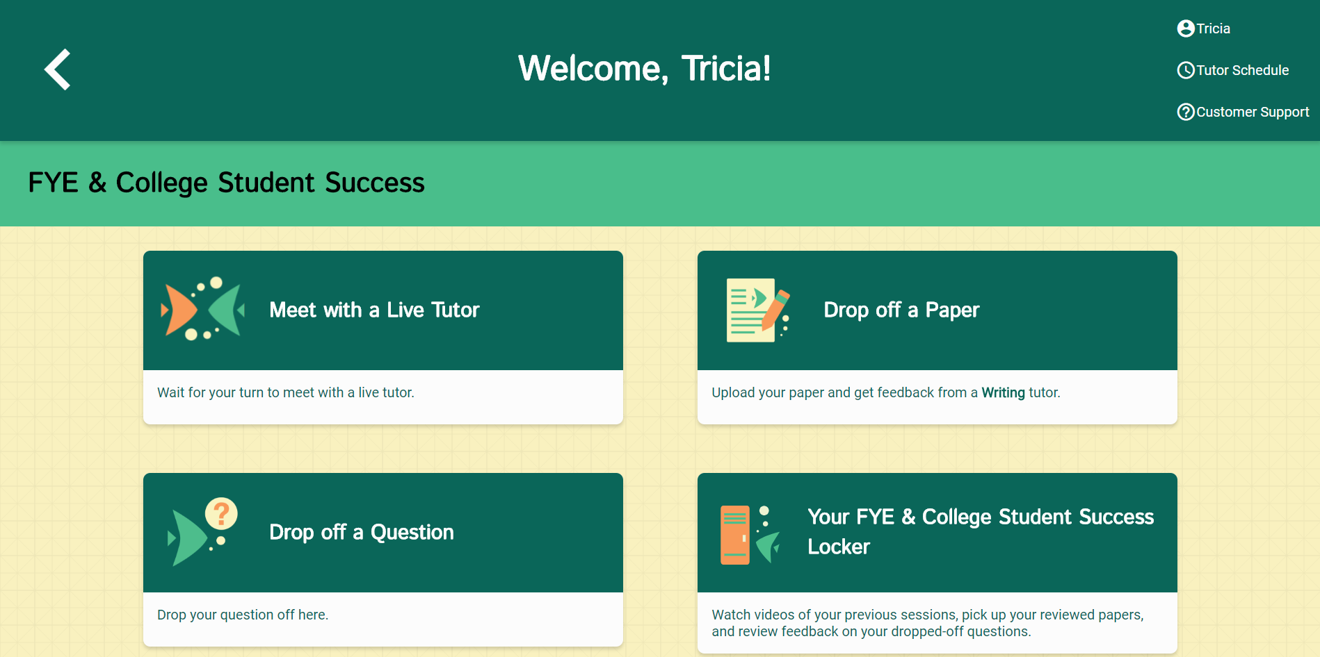

The NetTutor Dashboard
Meet with a Live Tutor: 4
Drop off a Paper: 4
Drop off a Question: 6
The Locker: 7

Meet with a Live Tutor:
Directs you to an information page where a tutor will be available soon.

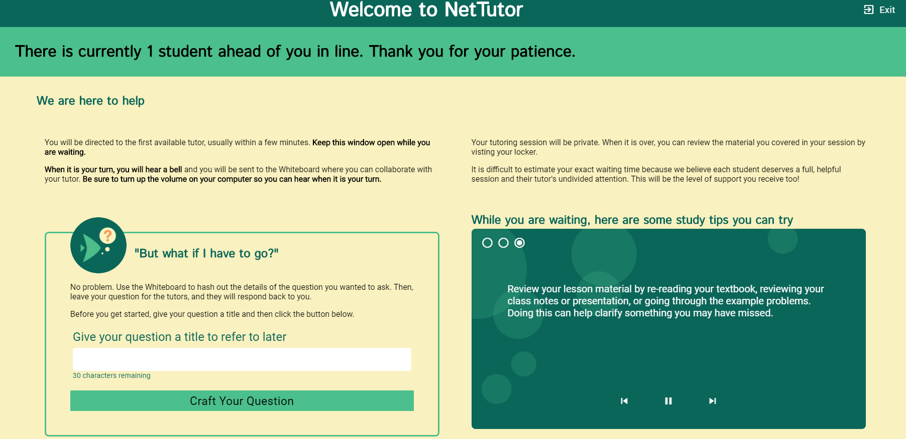

Drop off a Paper:
Directs you through three prompt to drop off your paper.

First, name your paper and describe the assignment.

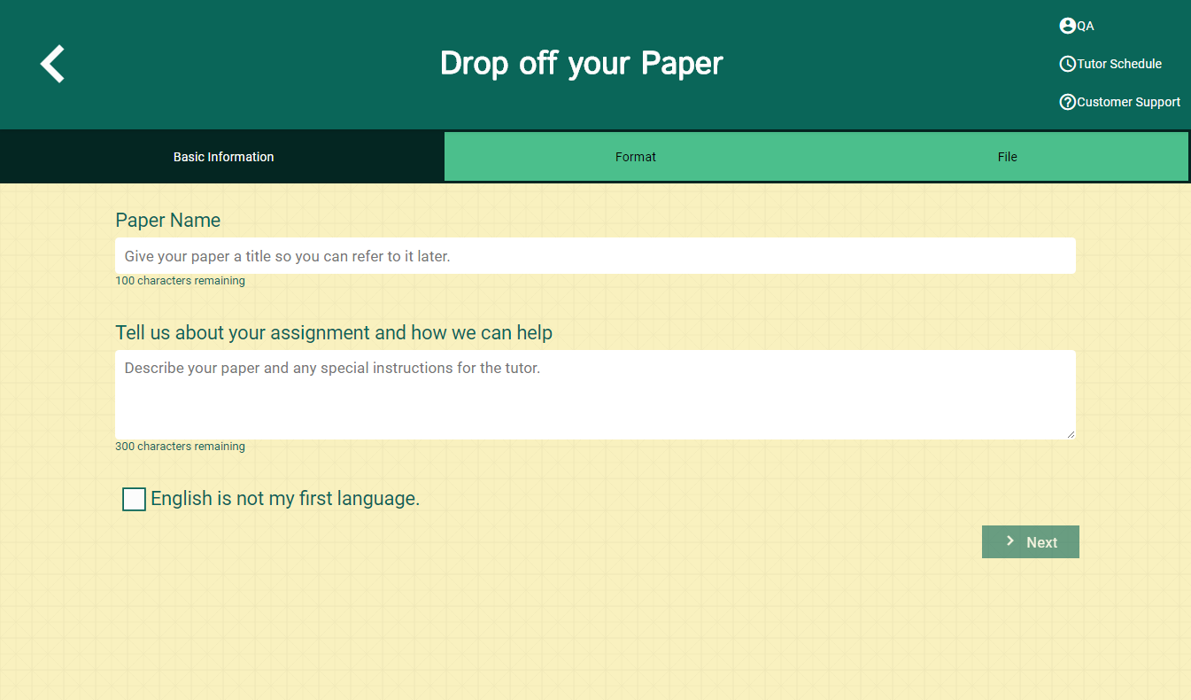

Second, tell the tutor what you need help with.

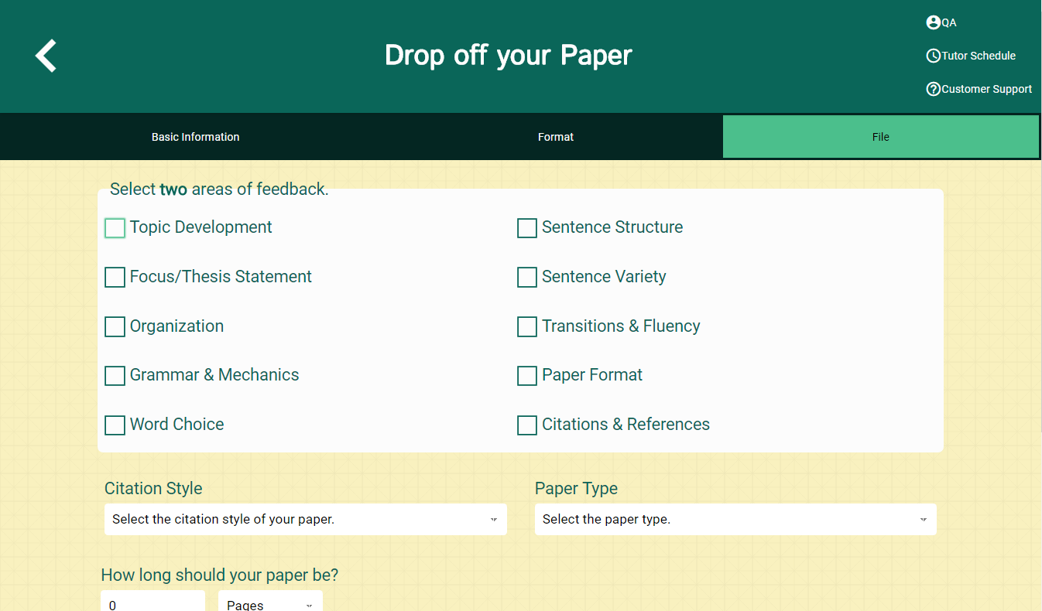

Third, upload your paper. Papers have a turnaround time of 48-72 hours.

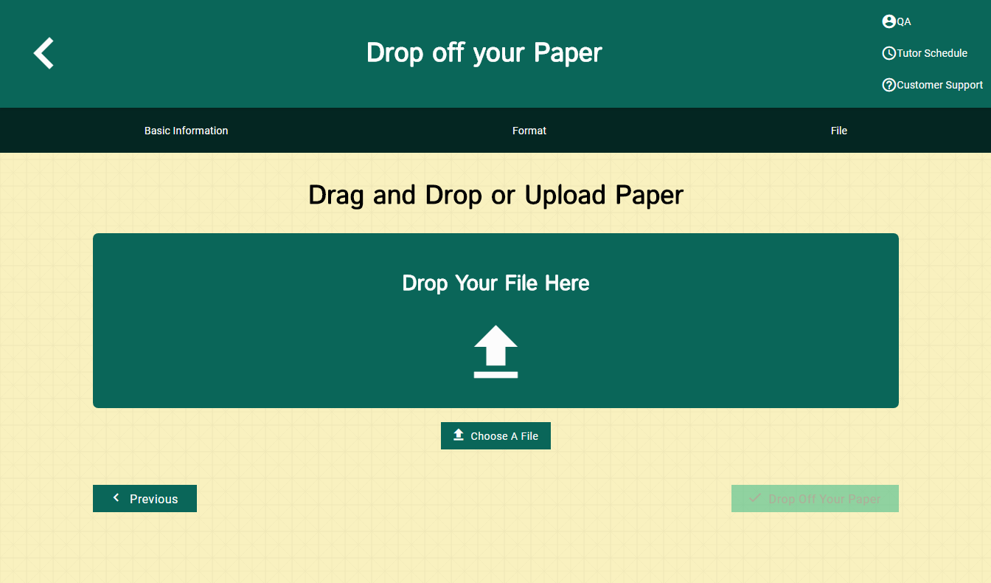

Drop off a Question:
Directs you through two prompts to drop off your paper

First, name your question.

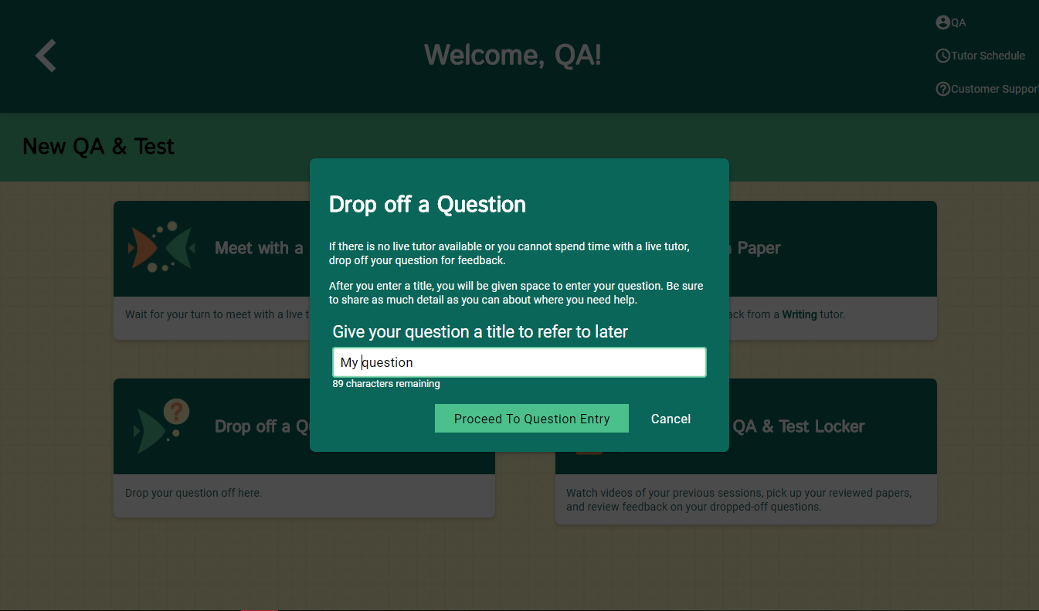

Second, use the white board to ask your question. Once you have finished your question, click the “Submit” button in the lower left-hand corner.
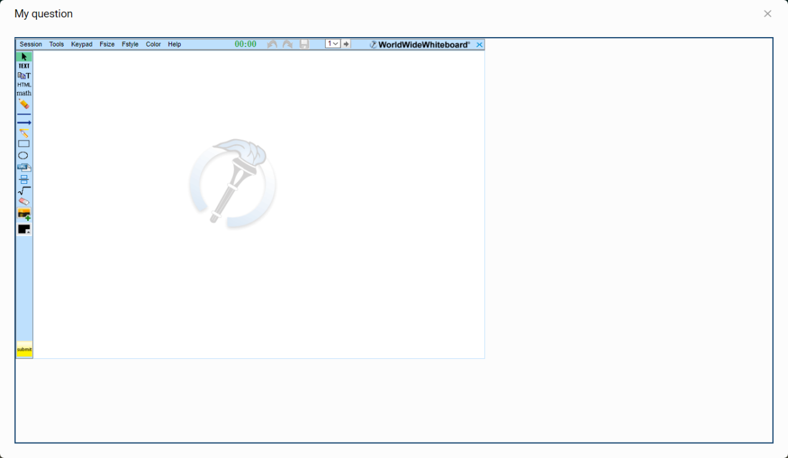

The Locker:
Your locker stores all your NetTutor sessions. You can review your live tutoring sessions, retrieve papers you have submitted for feedback, or gather responses to your submitted questions.

